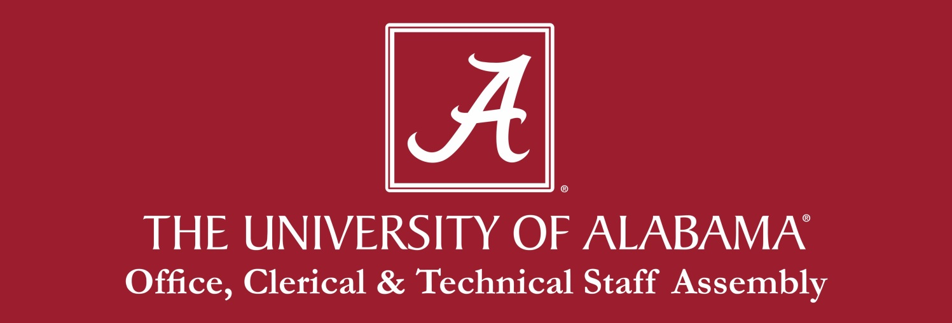

OFFICERS

2012/2013
President: Allyson Holliday
President-elect: Sherry Phillips
Secretary: Renae Sullivan
Treasurer: Alesia Darling
Parliamentarian: Kevin Ray

2013/2014
President: Sherry Phillips
President elect: Heath Nails
Secretary: Dee Cook
Treasurer: Carolyn Fulmer
Past-President: Allyson Holliday
Parliamentarian: Kevin Ray

2014/2015
President: Dee Cook
President elect: Todd Hester
Secretary: Lacee Nisbett
Treasurer: Lynette Scales
Parliamentarian: Cassie Schultz
Past-President: Allyson Holliday

2015/2016
President: Todd Hester
President elect: Lacee Nisbett (stepped down – Allyson Holliday took over)
Secretary: Dianne Gilbert
Treasurer: Marina Klaric
Past-President: Allyson Holliday

2016/2017
President: Allyson Holliday
President-elect: Jessica Richardson
Treasurer: Lacee Nisbett
Secretary: Marina Klaric
Past-President/Parliamentarian: Todd Hester

2017/2018
President: Jessica Richardson
President-elect: Todd Hester
Treasurer: Leslie Davis
Secretary: Azia Patrick
Past-President/Parliamentarian: Allyson Holliday

2018/2019
President: Todd Hester
President-elect: Angel Narvaez-Lugo
Treasurer: Leslie Davis
Secretary: Darlene Smith
Past-President/Parliamentarian: Allyson Holliday

